**Practical 17:**

**Aim:-Create web application to generate report.**

1.Create Date Set

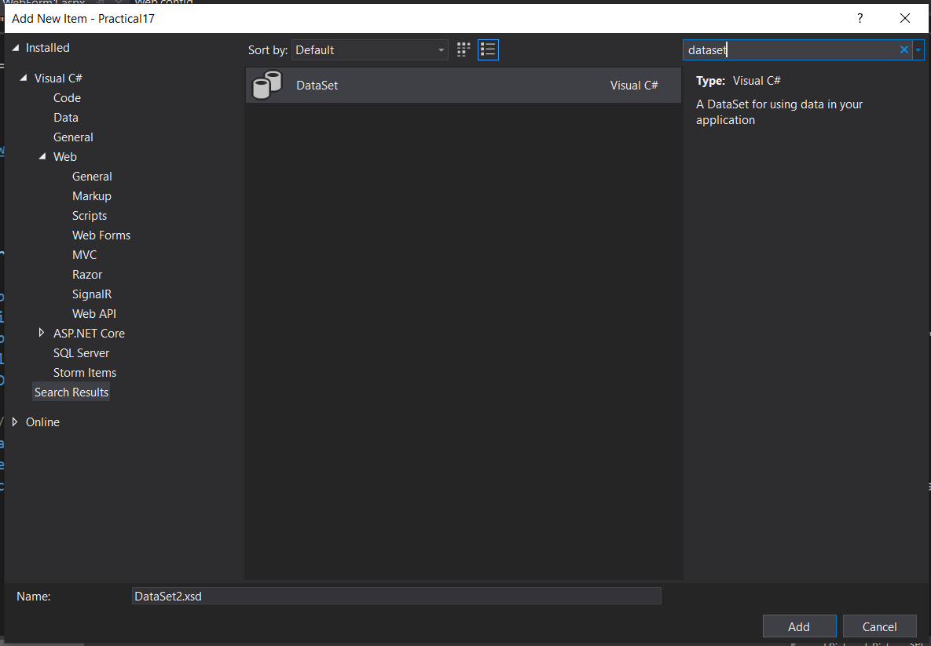

Click On Add Connection

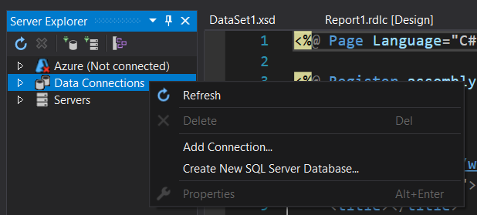

**Browse database file and then click ok**

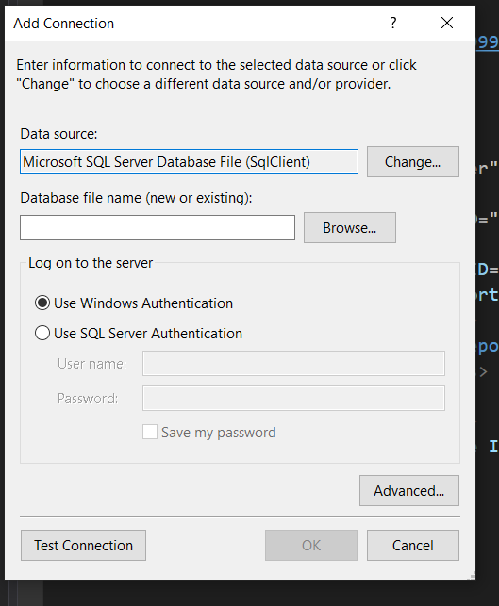

Open DataSet.xsd file and right click on it then click on Add the click on TableAdapter

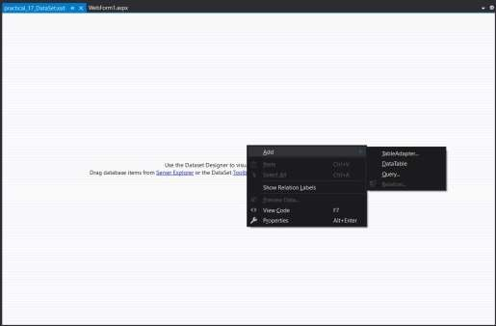

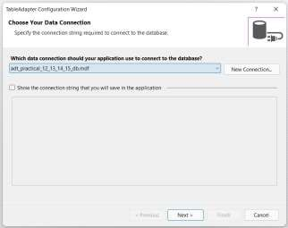

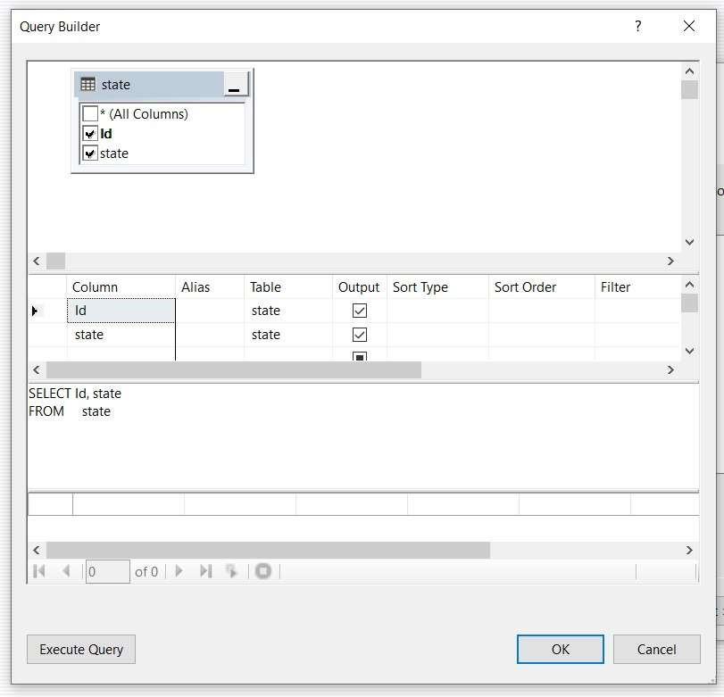

Then Add Report1.rdlc file

# Add WebForm in over Project In WebForm Add ScriptManager and ReportViewer from toolbox Then click on right side arrow key the choose your report

Then Run

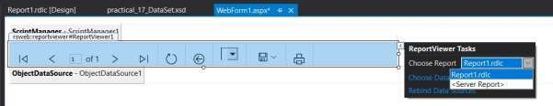

OUTPUT:

